Manual for How to Take the BEVI [Post-Program]
Step 1: Log in to the BEVI
1. http://jp.thebevi.com/test-admin/
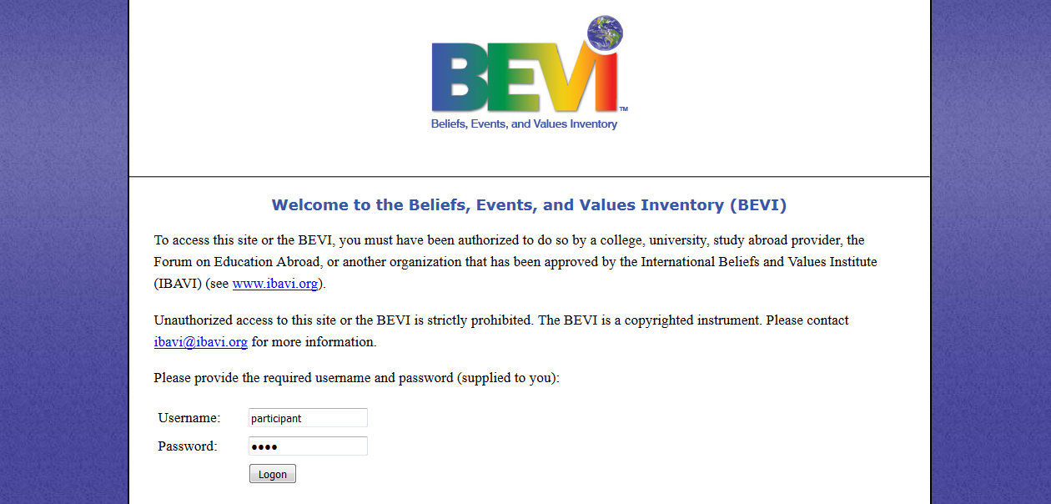

2. Enter the following set of username and password into the appropriate box.
Username： participant
Password： bevi

3. Click “Logon.”

4. Read through the instructions and click “Start.”
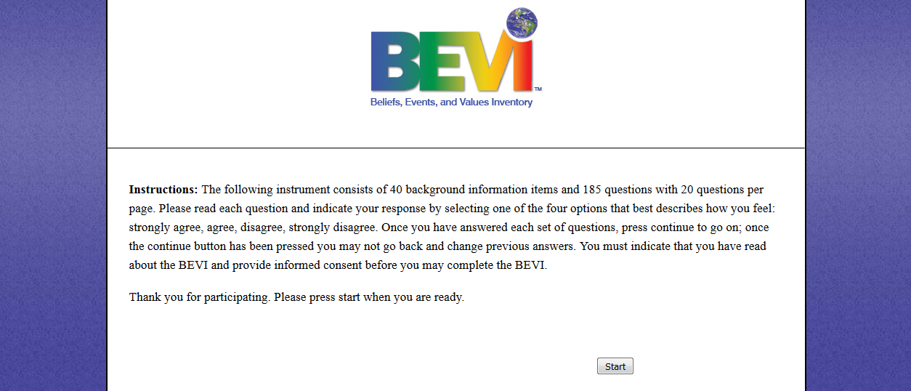
5. Read through the consent form and click “Agree.”
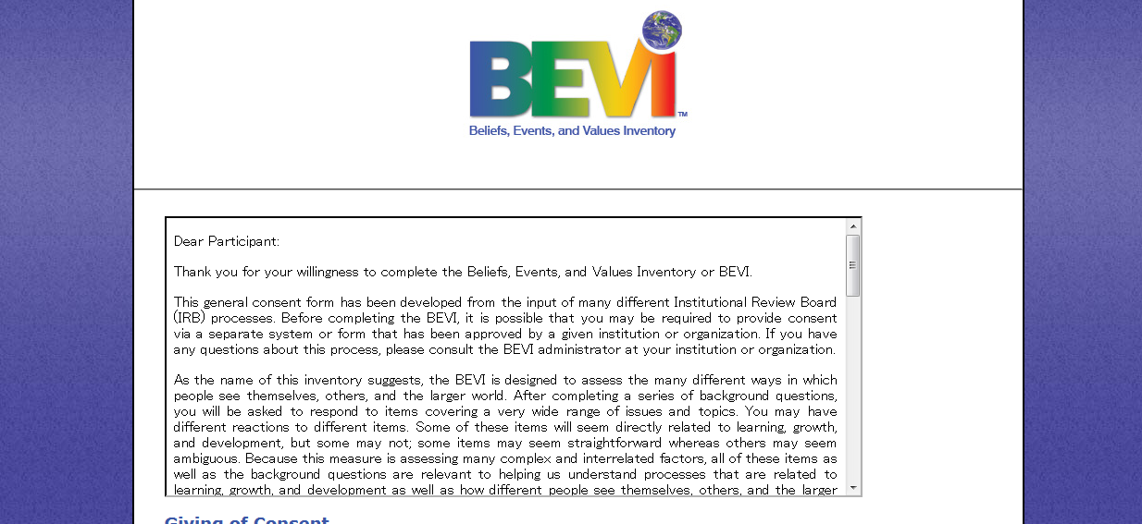

6. Click “No, I want to submit a new BEVI.”
Please change
Step 2: Complete the “Background Information” questions
1. Select “Hiroshima University” from pull down menu.
Please change
2. For the next question “For what program/course/experience are you taking BEVI
(please provide the name),” please select the most appropriate program name from pull down menu, according to the duration of your stay in Hiroshima (please refer to the table below). After selecting your program name, you can skip over the “Other” box to the next question.

Please change
Duration of Your Stay | Program Name
Less than 30 days (1 month) | 2018-PEACE-A
30 days or more but less than 90 days (3 month) | 2018-PEACE-B
90 days or more but less than 180 days (6 months) | 2018-PEACE-C
180 days or more but less than 365 days (1 year) | 2018-PEACE-D

Skip this part
2018-PEACE-A/B/C/D

Hiroshima University
After

3. For “your ID number,” please accurately enter your email address.
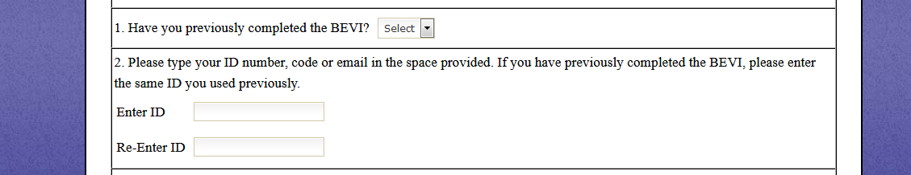
Your University Email Account
Yes

4. Please continue to answer the rest of the questions in the test. While answering these background questions, you may encounter some unfamiliar terms, in which case you can consult a dictionary and/or use Internet search engines.

Step 3: Complete the BEVI test items
1. Please answer each item. Don’t think too much but follow your intuition when answering these questions.

2. After the completion of all test items, you will see the following screen where you are asked to answer some open-ended questions, based on your experiences abroad.

3. Immediately after you finish the BEVI, you should receive an individually customized report at your registered email address.
Please change

This test-taking manual, which was prepared by Hiroshima University for its international exchange students, aims to provide step-by-step instructions for them to follow. Please do not circulate or place this document on the internet.
If you cannot find your report in your email box, please contact Mr. Atsushi Nagai, Assistant Professor (Special Appointment), International Center, Hiroshima University at anagai@hiroshima-u.ac.jp.

